PRALLETHRIN ULTRA LOW VOLUME SOLUTIONS
*743/LV/M-

- Sampling. Take at least 200ml

- Identity tests. As for Prallethrin Liquid Vaporizer 743/LV/M/- CIPAC L, page 117. An additional GC-MS identity test is proposed for UL formulations as outlined below:

The following instrument parameters were utilized in the GC/MS analysis:
Oven Program | 50ºC for 2 minutes  10ºC/min to 250ºC for 5 min  10ºC/min to 325ºC for 10min
Run time | 44.5min, Prallethrin ret. time ca 19.9 min
Inlet Temperature | 325ºC
Injection Volume | 1µL
Split Injection – Split flow | 100mL/min
Flow velocity | Helium at 45cm/s
Column | Agilent HP-5ms: 30m x 250µm x 0.25µm
MSD Transfer Line | 335ºC
MS Source | 230ºC
MS Quad | 150ºC
Solvent Delay | 5min

Prallethrin is identified in the standard and sample solution with a clear peak which matched the NIST library search for prallethrin, containing the major ion fragment of 123 AMU.

- Prallethrin. As for Prallethrin Liquid Vaporizer 743/LV/M/- CIPAC L, page 117 except
- Detector temperature and Inlet temperature both changed to 325ºC.
- If specific UL formulations are demonstrating a matrix effect (e.g. suppression or amplification of the analyte signal), then quantitation by the method of standard addition is acceptable.
Figure 1. Prallethrin standard solution analysis – GC/MS
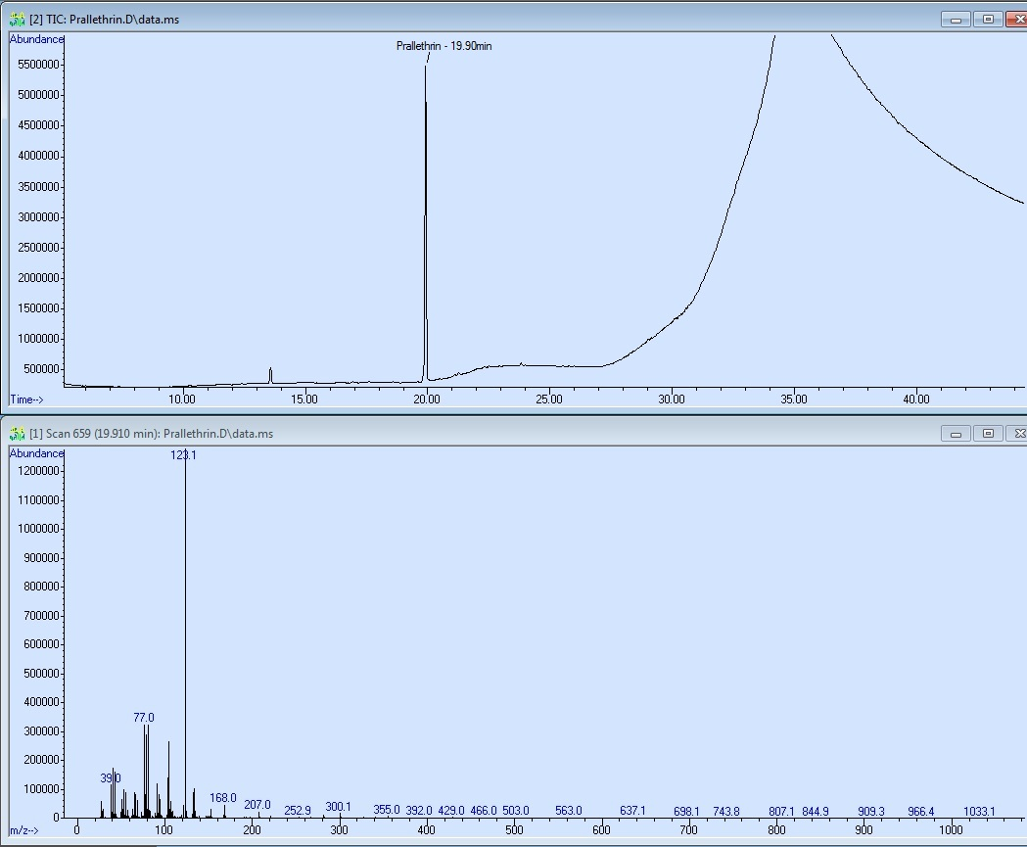
Figure 2. Formulation Analysis for Prallethrin – GC/MS
